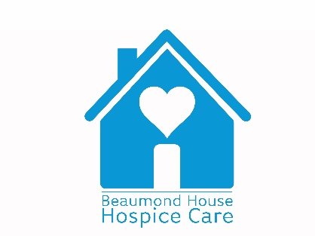

Expression of Interest in taking part in research at Beaumond House Hospice

Name | Date
Institution/University

Key area of research e.g. patient/friends/carer relationships, nutrition, clinical care, stroke etc.

Please give a brief summary of the research to be undertaken:

Anticipated duration of your research?

The Hospice does not fund research directly.
Do you already have funding? | Y/N
Yet to be determined? | Y/N
Are you looking to make a joint grant funding proposal? | Y/N

Please contact Louise Sinclair for an informal discussion.
Louise.sinclair@beaumondhouse.co.uk

