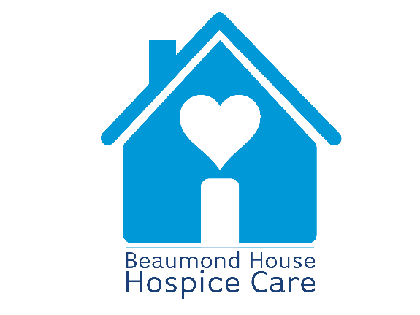

Tell us what you think ……

...comment...
...compliment…
...suggestion…
...concern…
...complaint…

The feedback we receive from patients, family and friends contributes to our compliance with the clinical guidelines for ‘Patient experience in adult NHS services: improving the experience of care for people using adult NHS services’. Updated June 2021.
Many people receive help and support from Beaumond House and it is important for us to hear how we are doing. This will help ensure we continue to improve the services we provide. We want to promote a clear, open and responsive caring environment and value comments and suggestions. We also need to make sure you know how to make a complaint if you need to. Please use this form to tell us if:
- something was done particularly well
- you have any comments or suggestions about how things could be done better
- you were dissatisfied with something or wish to make a complaint.
I would like to tell you about………………………………………
…………………………………………………………………………
…………………………………………………………………………
…………………………………………………………………………
…………………………………………………………………………
…………………………………………………………………………
…………………………………………………………………………
…………………………………………………………………………
…………………………………………………………………………
…………………………………………………………………………
…………………………………………………………………………
………………………………………………………………………...
Name………………………………………………………………….
Address……………………………………………………………….
…………………………………………………………………………
Telephone……………………………………………………………
Although most people accessing our care services receive excellent support, sometimes things can be improved. We would like to add that if for any reason you are not happy with the care or treatment you receive you have the right to complain, to have your complaint investigated and be given a full and prompt reply.
To make a complaint please contact the hospice by either:
Calling 01636 610556 and asking to speak to Louise Sinclair, Chief Executive or Karen Brown, Head of Clinical Services
Alternatively, if you would prefer to put your concern in writing, please address it to:
Louise Sinclair, Chief Executive, Beaumond House Hospice Care, 32 London Road, Newark, Nottinghamshire NG24 1TW.
When you contact us please include a clear and detailed description of what your complaint is about together with your contact details so that we can respond to you.
Our complaints policy can be accessed via our website or by requesting a copy from Reception at Beaumond House on 01636 610556.

Whilst we would always prefer to be given the opportunity to answer complaints first, if you wish to complain to an independent agency, you may contact the following:

NHS Nottingham and Nottinghamshire Integrated Care Board

- By phoning the Patient Experience Team on 0115 8839570
- By emailing nnicb-nn.patientexperience@nhs.net
- By writing to NHS Nottingham and Nottinghamshire Integrated Care Board, Sir John Robinson House, Sir John Robinson Way, Arnold, Nottingham, NG5 6DA
- On-line at Patient Experience and Complaints - NHS Nottingham and Nottinghamshire ICB

Parliamentary and Health Service Ombudsman
(please note the Ombudsman will usually only investigate after Beaumond House Complaints Policy completed).
- By phoning 0345 0154033
- On-line at http://www.ombudsman.org.uk/make-a-complaint/how-to-complain

Care Quality Commission
- By phoning 03000 616161
- By emailing enquiries@cqc.org.uk
- On-line at www.cqc.org.uk

POHWER Advocacy Service (an independent organisation who are able to speak on your behalf if you want to raise a concern)
- By phoning 0300 456 2370
- By email feedback@pohwer.net
- By writing to: PO Box 14043, Birmingham, B6 9BL
- Website: www.pohwer.net/
For Beaumond House use.
Reference number ………………………….. Date and time received ………………………………………….
Person responsible for action ……………………………………………………………………………..
Leaflet updated June 2022 – U/drive Apatient care/ Leaflets/Tell us

