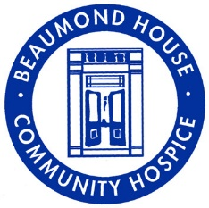

Beaumond House

Our Workforce Strategy
2018 - 2023

Section Contents Page
- Message from the Chair of the HR Sub Committee 3
- About Beaumond House 3
- Beaumond House Vision and Values 3
- Equal Opportunities 4
- Achievements of the last 12 months 4
- Hospice UK HR Survey results 5
- Recruitment and retention 6
- Delivering our Strategy 7
- Organisation and Design 9
- Learning and Development 9
- Culture 11
- In Summary 12

1) Message from Chair of H R Sub-committee – David Tomkinson
It is my privilege to introduce this workforce strategy. Our workforce includes contracted and bank staff and volunteers. Without everyone we would not be able to provide the high-quality care services that Beaumond House delivers.
This workforce strategy sets out our ambitions and the key challenges facing us during the next five years. The Board of Directors and the Leadership Team are committed to continuous learning and development and investing in our workforce. We want to start by saying thank you for all your hard work, your dedication, and the extra mile that everyone goes for our patients.
We hope that through the transparency of our ambition, that together, we can build on the excellent palliative and end of life care in Newark and District that is currently provided and continue to further improve the flagship services we offer.

2) About Beaumond House

Through the blue doors of Beaumond House you will find a lively and vibrant space, filled with life and laughter. Our staff, volunteers and patients alike bring hope and happiness together in a ‘home from home. Patients are at the centre of all that we do. We therefore expect all those who come to join our team (in whatever capacity) to ensure that dignity, safety and confidentiality of all patients is respected at all times and that all patients receive the highest possible standard of physical, psychological and spiritual care.

3) Beaumond House Vision and Values

Our Mission is ‘Local Help for Local people’

We will work with integrity and PASSION to deliver individualised HOLISTIC CARE for patient and their families.
Create a HAPPY, SUPPORTIVE, atmosphere where staff and all volunteers can feel valued.
Develop true partnerships, benefitting all parties, inspiring CONFIDENCE and PRIDE
Have OPEN TRANSPARENT two-way communication, drawing REAL VALUE from all relationships.

4) Equal opportunities
Beaumond House Community Hospice is committed to the provision of equal opportunities in employment. Accordingly, Beaumond House wishes to ensure that no job applicant is treated less favourably on the grounds of disability, marital status, ethnic origin, nationality, colour, sexual orientation or religion nor is disadvantaged by the application of a rule, condition or requirement which cannot be justified in job related terms, or as a requirement of law.
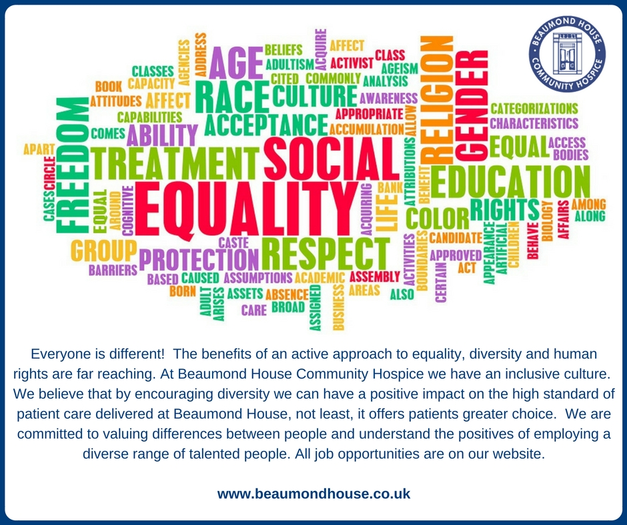

5) Achievements of the last 12 months (2017)
- Changed model of care for inpatient services
- Recruited differently to build a more diverse team – considering the local community we serve
- Fully recruited to nurse vacancies
- Improved our retention of current staff
- Successfully tested our business continuity plan
- Commenced succession planning
- Key policies reviewed and updated
- Working towards joint staff bank with a neighbouring hospice
- Provided innovative training and development
- Achieved the Mindful Employer accreditation
- Committed to be a Disability Confident Employer
Taken action to meet the following HR functional objectives:
- Ensure that the organisation structure and recruitment processes are set up to enable great people to thrive in great job roles.
- Develop a compensation and benefits package that attracts great people and rewards flagship performance.
- Create a training and development plan that grows capability and releases potential, to grow our own talent for the future. To include, continuity, and resilience across all functions through multi-tasking.
- Create an internal communications and engagement strategy that connects the organisation and ensures maximum engagement.
- Ensure that the HR structure and processes facilitate flagship service

6) Hospice UK HR Survey
Hospice UK recently did a HR survey. The five themes ranked of greatest value to address at national level included;
a. Workforce planning and development ranked top overall. In particular, current and future challenges were identified as: nurse recruitment and retention; recruitment of high calibre leaders; development of future leaders
b. Education and training provision e.g. developing the ‘care certificate’
c. Strategy and policies development, legislation updates and implementation e.g. Medical & Nursing Revalidation (Note legislation varies across the four nations).
d. Pay scales, terms and conditions, employee benefits e.g. agenda for change, volunteer roles
e. Benchmarking and sharing of good HR practice
We will review and reflect on each of these themes as we take forward action to implement our H R strategy.
7) Recruitment and Retention
We know that care services are changing. Demography, personalisation and funding issues have all come together to transform the care workforce. Within this transformation there is a need to understand the underlying reasons for change and to respond to them in positive, creative and dynamic ways.
The coming years will see a significant change in the way in which the population is structured. There will be a much higher ratio of older people compared with those of working age.
As life expectancy increases year on year, the numbers of people who will have care needs will dramatically increase. All this is happening at a time when the availability of people in the traditional workforce will be significantly declining.
In order to meet the challenges of the future, we will need to attract a diverse workforce. Traditional patterns of recruitment, structures and working practices will all have to change. Within the context of this diverse workforce, there will be a need to ensure consistency in terms of the quality of the workforce, the core values that underpin care work and the skills and competencies that staff will need to acquire.
Research from Skills for Care suggests that the skills required by care workers will move towards enablement, empowerment and facilitation. The future role will be about supporting people to be active and to help them lead as full a life as possible, not just delivering a service.
It is vital that Beaumond House takes every opportunity to share the views and experiences of the patients and relatives to communicate the impacts and outcomes of the care delivered. This reinforces the value of the care and in turn gives satisfaction to staff that delivered the care and emphasises job satisfaction to potential candidates. The patients and family experiences will be used in job adverts, job fairs and social media where consent is given.
The care sector is unusual in that the gender balance issues are more heavily weighted towards a predominantly female workforce and Beaumond House is no different. At Beaumond House we will commit to recruiting a balanced workforce and this strategy needs to consider equalising the proportion of men in our workforce.
It is important that the workforce is from all sections of the community including those of different ethnic backgrounds and that people with appropriate skills, knowledge and competencies are attracted to a career at Beaumond House.
Beaumond House is dedicated to nurturing new recruits and developing incentives for retention and career progression.
To ensure we retain a high-quality workforce we will develop some specific incentives that will help people remain in employment at Beaumond House. These will include: remuneration structures, additional benefits, e.g. pensions, health cover, life insurance etc and develop the Flagship Awards for a high-level performance. We want to incentive continuous professional development with rewards for qualification attainment and length of service.
Beaumond House is committed to providing opportunities for promotion and progression.
8) Delivering our strategy
Our Workforce Strategy aims to ensure we have the right people with the right skills to help us deliver services across Newark and surrounding areas now and in the future. We want to invest and develop all of our employees and build talent.
It looks at how we can effectively recognise employees for their commitment, hard work and good performance, are developed to have the knowledge and skills they need to adapt to the changing needs of our communities and how people can work smarter and more efficiently.
We know that some of our employment policies and practices need revision we need to put in place measures to make sure that these are all consistent so that we treat everyone fairly. We want to make our employment policies clearer and easier. This will help to improve our working relationships, our performance and service delivery.
We need to review our current pay, reward and benefits framework to look at developing different options that make sure we have a fair and transparent system in place.
To retain key skills and attract new employees. Beaumond House needs to establish its reputation as an employer of choice.
The hospice workforce of the future will need to evolve and adapt in order to keep up with the numerous changes we will see in palliative and end of life care in the next few years.
Learning and development – talent management
As part of our workforce people strategy we have promised to “enable and support every individual to realise the impact of working at their optimum performance.” So, regardless of the role we think that there are a set of skills all of us need to develop our talent and pursue the extraordinary to become Flagship.
Our four themes are:
- How we create and innovate
- How we influence and network
- Understanding how we impact on others
- How we make decisions
We have also shaped the resources around these three big ideas:
- Development is everywhere - It's not just about attending courses.
- My Development is my responsibility - be proactive about the development that you need
- Thinking is the beginning - The first stage of development is giving some thought to the development needed.
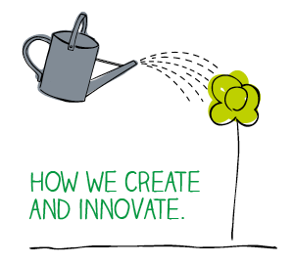
Vision
The vision for the workforce is that by 2021 staff will:
- the right RN/HCA ratio to support patients
- have the right skills, development and career pathways to continue to provide specialist palliative care to the people of Newark and surrounding areas
- through effective systems leadership, be part of the wider health care professionals across Newark and surrounding areas leading to the provision of care across the diverse population.
- have access to their own health and wellbeing services that will support regular attendance at work
- have a ‘voice’, be engaged in the development of their services and rewarded/remunerated appropriately for good performance
- be supported to be inclusive and comfortable with who they are, reflecting the diversity of the population
9) Organisation design
At Beaumond House the organisation design is the process of aligning the structure with its mission which supports the strategy to provide a safe effective, responsive, caring and well led service enabling patients and families to exercise choice at the end of life, with dignity. Beaumond House constantly reviews the staffing structure to ensure it both enhances and is in line with all services, enabling flexibility around patient’s needs.
10) Learning and Development

Our learning and development strategy outlines how it develops the workforce's capabilities, skills and competencies to remain a flagship for end of life care.

It is an important part of the overall business strategy influencing not only the learning and development strategy but also the operational and cultural factors. Finally, considers the practical elements of implementing a learning and development strategy including the role of line managers.

All Line Managers carry out staff performance and development reviews (appraisals). This is just one of many tools that aim to ensure employees’ performance contributes to Beaumond Houses objectives and is used as part of a holistic approach to help people be at their best. Each employee has a regular ‘performance conversations’ in the form of an individual supervision session known as a ‘One to One’. Performance feedback and appraisals remain a crucial aspect to delivering the highest standard of care.
These are regular meetings which engender a culture of trust and openness to ensure all employees are receptive, prepared to align with business objectives, learn and take responsibility for their performance. We take a reflective approach to whether things could be better. These meetings are constructive with a clear purpose, to inform management decisions and employee development. They help with recognition of achievements. They are an opportunity for two-way conversation and reflection and agreed action plans/objectives.
Development Plans
At Beaumond House there are informal training plans where there is no specified outcome or evaluation where development happens naturally. An example would be learning from other people and from reflecting on experiences.
We encourage informal group discussions on certain topics to share knowledge. We utilise reflections to see where we can improve.
In our formal development training plans there are clear learning objectives and outcomes.
We have champions who are a nominated specialist in different areas.
We utilise funded courses such as National Vocational Qualifications (NVQs).
At Beaumond House we pride ourselves on the high standard of care that we deliver. Employees and volunteers all play a part in delivering the care directly or indirectly. Many employees and volunteers give their time freely and go above and beyond to recognise this we have developed a scheme called the Flagship Awards.
The Beaumond House Vision is ‘we will be a flagship provider for people with life limiting conditions’. To recognise examples of Flagship Care and Service nomination forms are completed by patients, relatives, employees and volunteers these nominations are then collated and evaluated by a panel of Directors, staff and volunteers who meet once a quarter and discuss the nominations. We encourage all staff and volunteers to aspire to be flagship.
We aim to be trainers for palliative care for care providers within the community. Redirecting funding back into the income stream and to raise standards throughout local care providers. Development is linked to succession planning and attracting and retaining the talent pool.
11) Culture
The culture at Beaumond House encompasses values and positive behaviours that contribute to the unique environment at Beaumond House.
Our Mission is ‘Local Help for Local People’

At Beaumond House we work with integrity and passion to deliver individualised holistic care for patient and their families. Creating a happy, supportive, atmosphere where staff and all volunteers can feel valued. We develop true partnerships, benefitting all parties, inspiring confidence and pride. We have open transparent two-way communication, drawing real value from all relationships. Literally, every manager's door is open to every employee. The purpose is to encourage open communication, feedback and discussion about any matter of importance.

In addition to the open-door culture, we issue an annual staff survey to get a better understanding of employee morale, satisfaction, and engagement opinions are important to us, and the survey is a chance to express any opinion.
We share the results and also what we did to improve our culture and performance and address any problem areas that are highlighted.
We have a staff “SHOUT OUT” Board which works by anyone thinking of a volunteer or member of staff who have been doing a fabulous job lately or someone who has helped you out.
We ask people to grab the chalk pens and write down a Big Thank You. Then smile about making someone’s day ☺

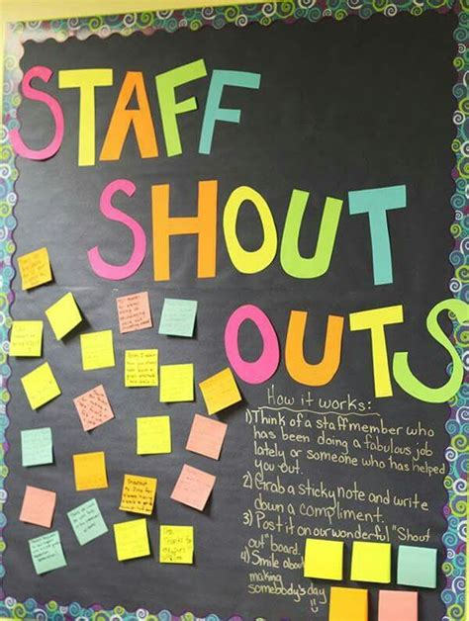

12) In Summary
All staff are valuable to the organisation and are very much valued by patients, the Board of Directors and the Leadership Team. We will, as we implement this strategy consult further with staff on translating this ambition into action. As stated earlier our overall vision is to ensure we continue to recruit staff with the right values, ensure we provide relevant training so staff have the right competencies, and provide supervision and support to effectively deliver our services. Ultimately, this approach, together with our employment package will enable us to retain the expertise of staff to provide safe, effective, caring and responsive services that are well-led.

